**How to Prepare Files for Waterjet Cutting in Team Lab**

Made by: Mark Diny

Year: 221 Season

Table of Contents

Saving the DXF 2

Naming the File 2

Contacting Mike 3

# Saving the DXF

*SolidWorks makes it super easy*

1. Right click the top side of your part (the face that would be orientated up in the waterjet), and click “Export to DXF/DWG”
   1. Save it in the appropriate subversion folder. Chassis folders should (hopefully) have a “DXF, STEP, etc” folder.

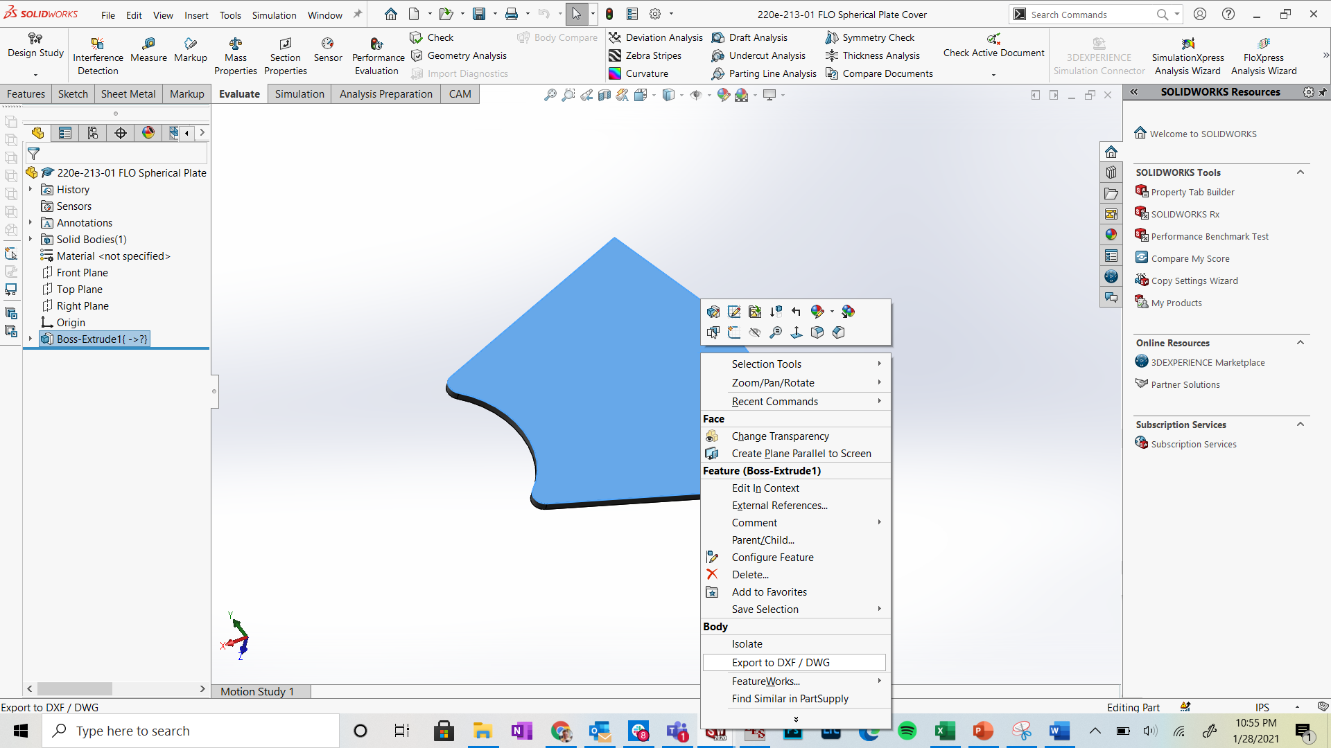

1. Select “Sheet Metal” on left of screen if the part is bent

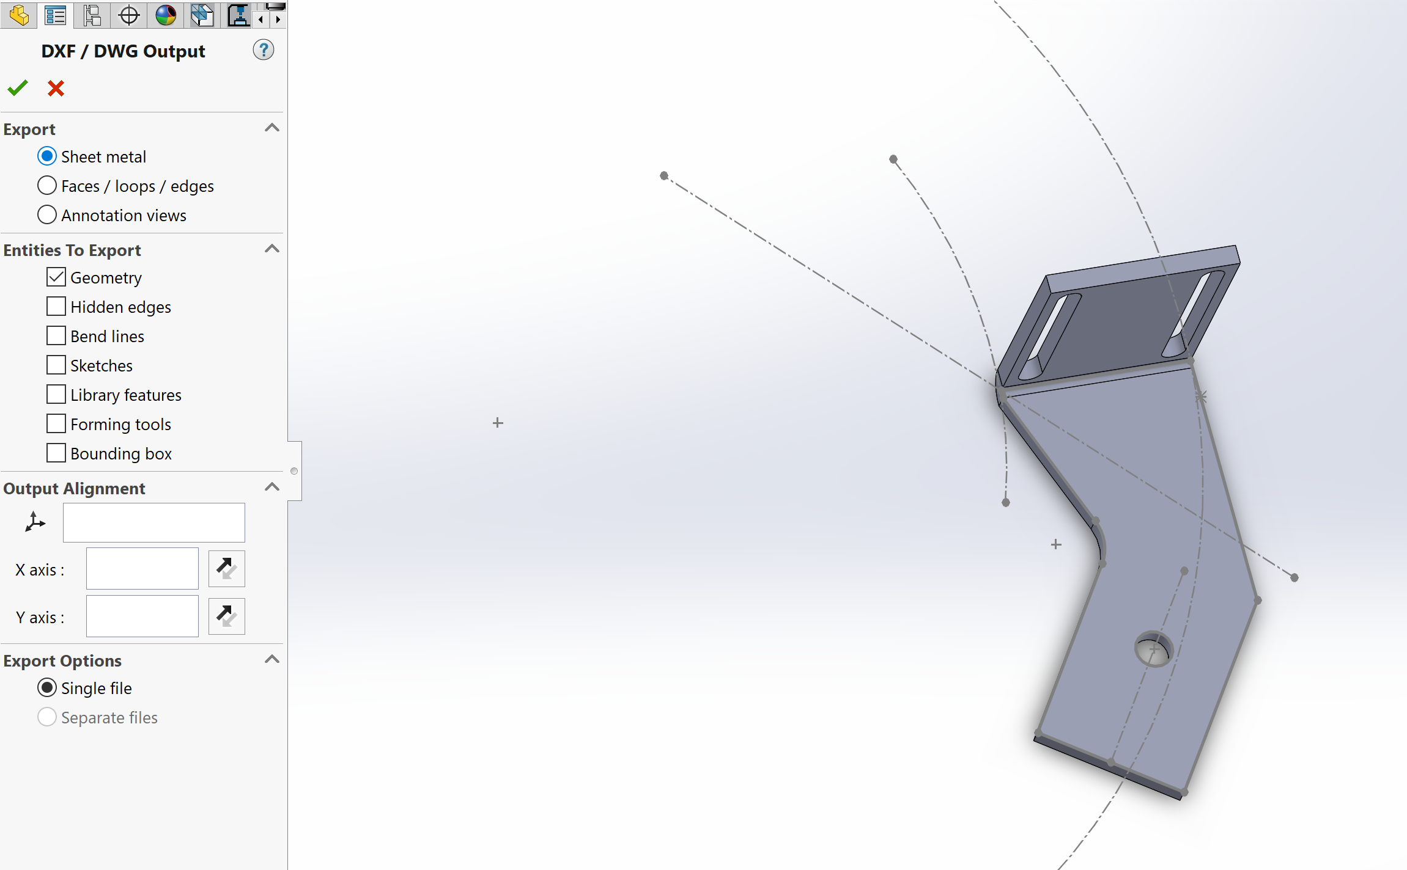

1. **DO NOT save your part drawing as a DXF**. There are a lot of unnecessary lines there which are annoying to delete for Mike
   1. SolidWorks naturally has graphics in their DXF, that is ok. There is no way around it.

## Naming the File

*Since this only goes from you to Mike downstairs, make it easy*

1. Save your file with its regular file name, but at the beginning add:
   1. QTY X, THICKNESS MATERIAL,
   2. **Example:** QTY 4, 0.1 4130, 220e-522-10 Inverter Mount

# Contacting Mike

*Mike is located in the HAAS room downstairs. He’s super nice and will help us out whenever*

1. Check the Team Lab waterjet website for updates, but fill out the form on the link below.
   1. <https://teamlab.engr.wisc.edu/services/waterjet-cutting>
   2. If it asks for the DXFs, just say that you emailed them to Mike
2. Email Mike the DXFs with the proper file name
   1. Hughes3@wisc.edu
   2. If a large amount of files, make a list using the “Waterjet Template” in Google Drive
3. Ask him how he wants the material delivered in the email